**Valentine’s Day 2022**

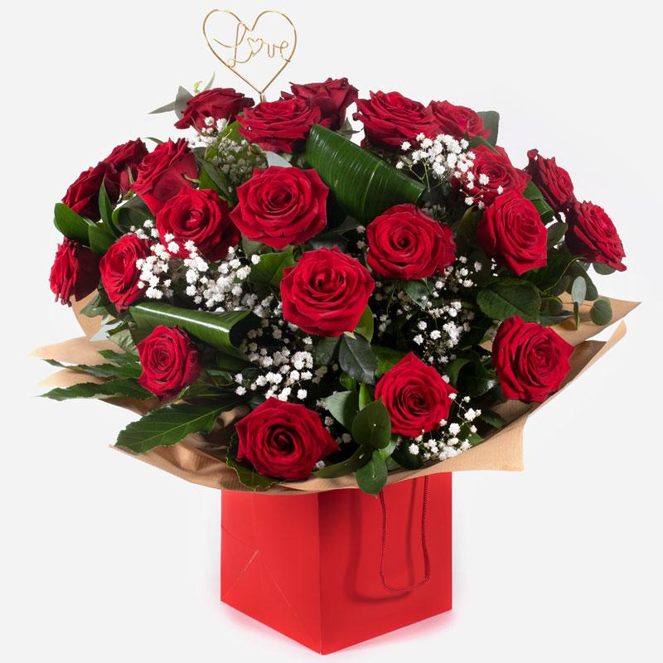

Ace of Hearts

Standard £135

Two dozen gorgeous red roses with a peppering of gyp and green. The definitive star of the show when it comes to flowers for loved ones.

*Workroom:*

A hand-tied of 24 high quality red roses complementary filler and foliage delivered in water wrapped in paper / cellophane in a gift box/ bag.

A novelty pick is added to enhance the design.

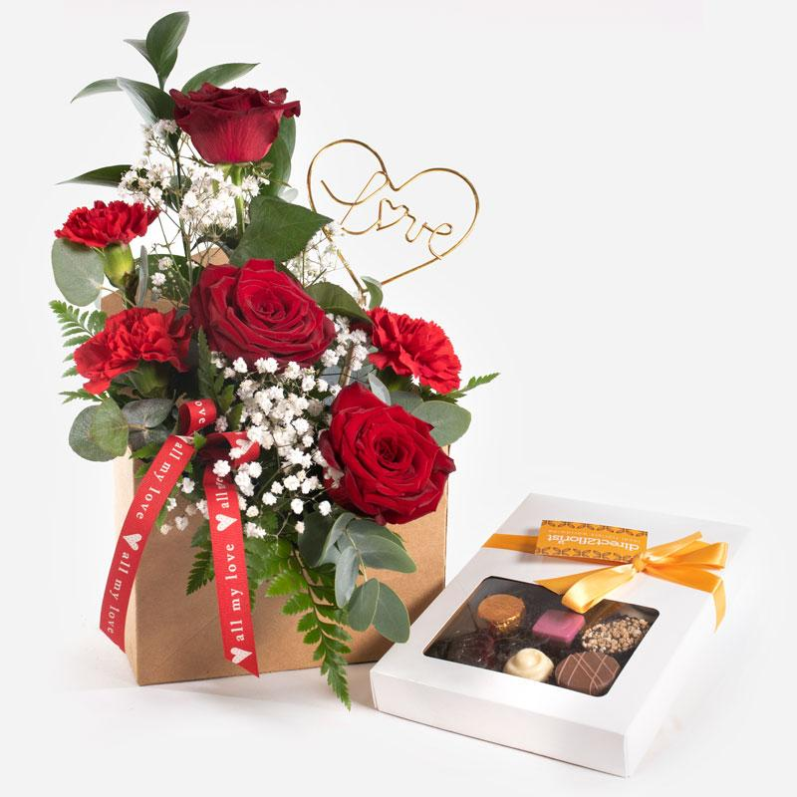

**Love Letter with Chocolates**

Send a message straight from your heart with this delightful envelope arrangement of romantic flowers accompanied by delicious chocolates.

Standard £44.50

*Workroom desc*

A kraft envelope was lined and filled with foam before making the design in long lasting foliage. 3 short red roses and 3 red carnations and complementary filler were then added along with a novelty pick and ribbon to complete.

This gift is delivered with a box of high quality chocolates.

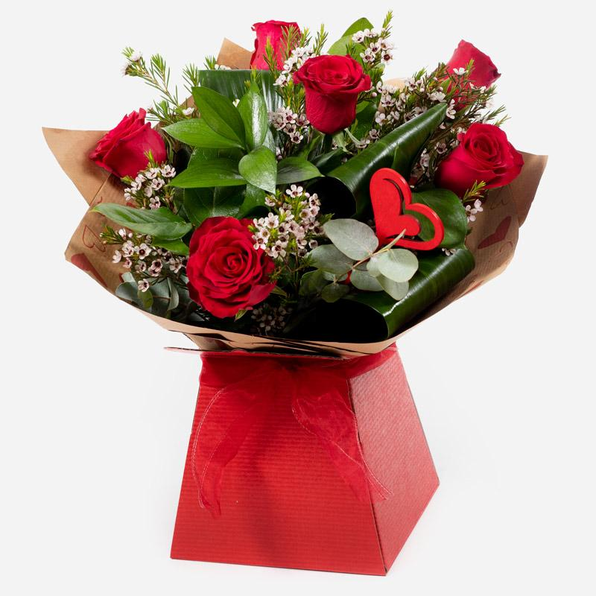

**Kissing Booth**

Who could resist you after receiving this selection of the beautiful red roses matched to the finest seasonal foliage.

Standard £39.50

*Workroom desc*

6 standard red roses hand-tied or arranged in Oasis with choice filler and foliage with a novelty item presented in a gift box or bag.

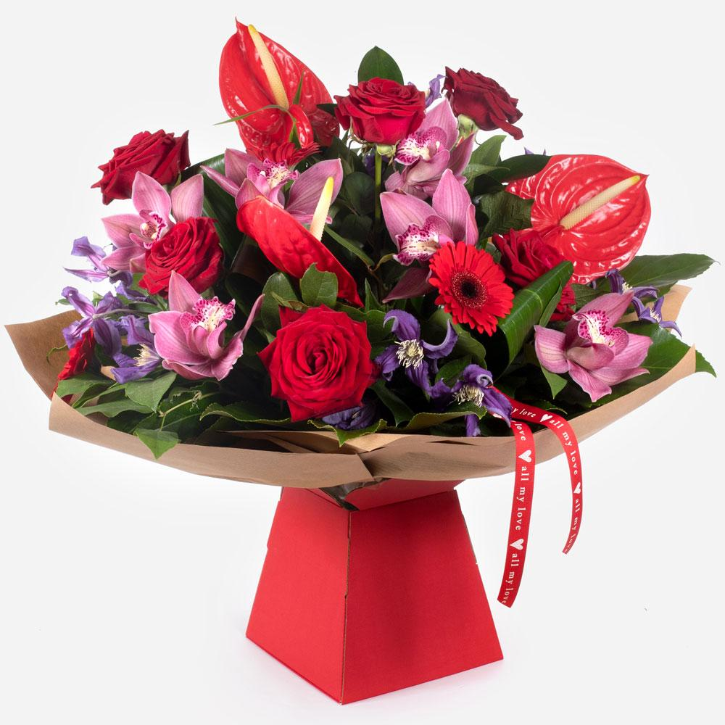

**Love Potion**

Standard £95 / £135 / £175

This outstanding bounty of blooms is guaranteed to wow that special someone. Who could fail to be overawed by such a bold statement of love.

Workroom:

A hand-tied luxury collection of flowers and foliage delivered in water in a gift box / bag. The single headed Orchids were put into water filled tubes on sticks. A novelty ribbon was used to enhance the design.

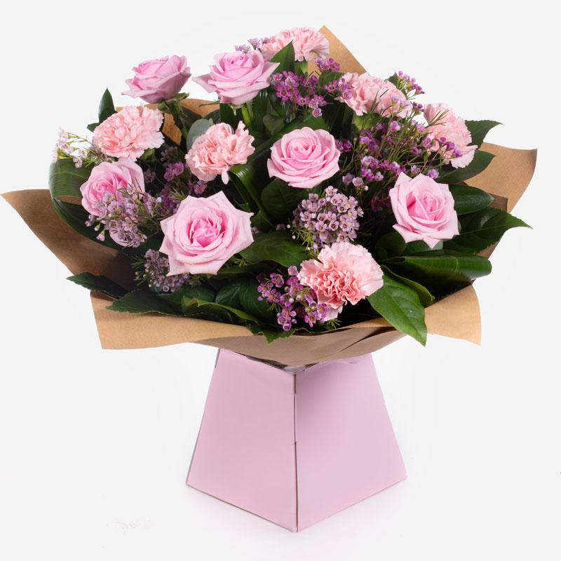

**Strawberry Twist**

Standard £49.50

This sweet arrangement of roses with carnations and foliage to compliment. Your recipient is sure to be overjoyed at such a heartfelt statement.

*Workroom:*

A hand-tied bouquet delivered in water of 6 high quality pink roses and 6 pink carnations with complementary filler wrapped in paper / cellophane in a box or bag.

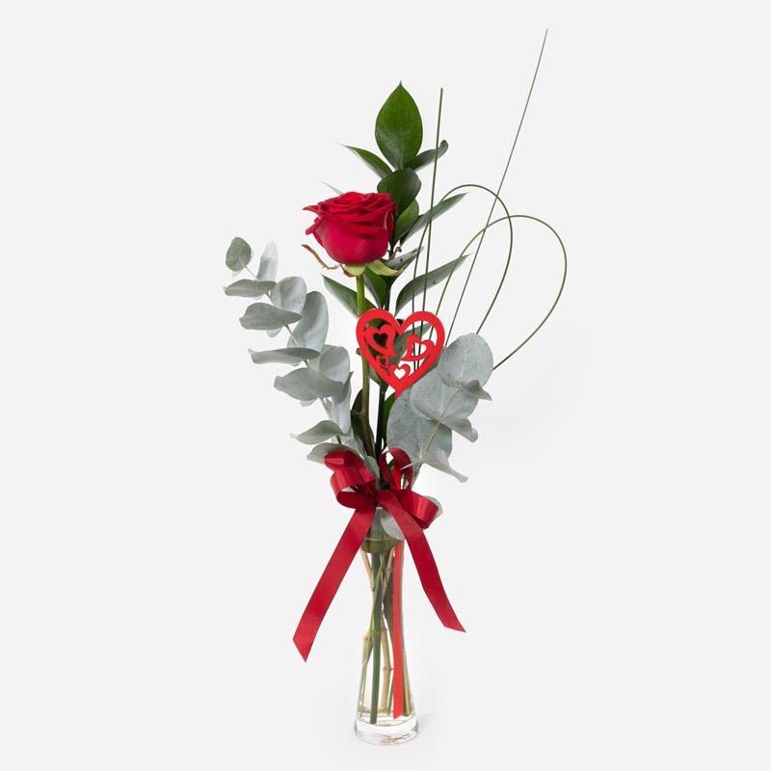

**A Little Treasure**

Leave a lasting impression with this single red rose, presented in a glass vase. Handmade & hand-delivered to the one you treasure.

Standard £25

*Workroom desc*

A single high quality rose is arranged in a stem vase with high quality choice foliage and a novelty item. Top tip: The ribbon is wired and the flowers are tied before putting into the vase to keep everything in place for delivery.

----

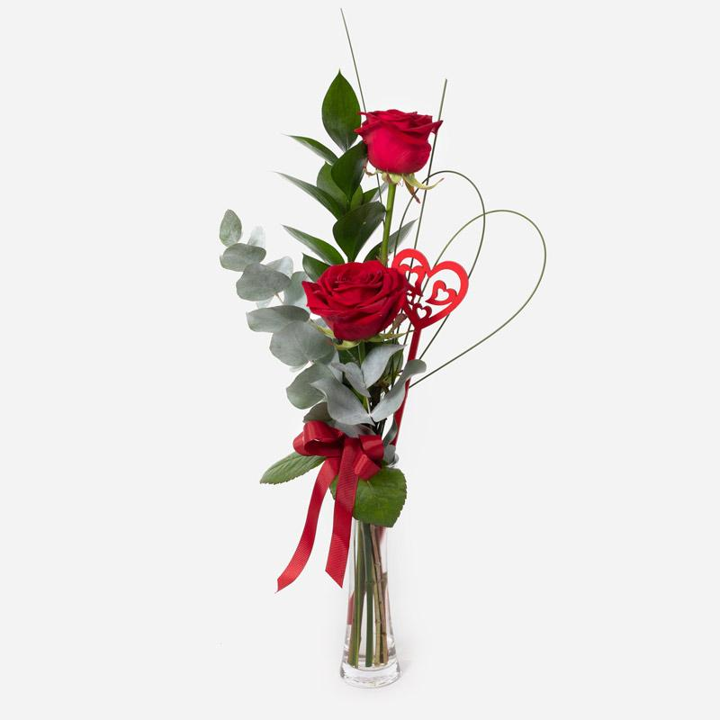

**Two Become One**

This delightful pairing of gorgeous roses with a contrast of foliage is a perfect gift for that special someone. Lovingly placed in a pretty vase made just for two.

Standard £32.50

*Workroom desc*

2 high quality red roses are arranged in a stem vase with high quality choice foliage and a novelty item. Top tip: The ribbon is wired and the flowers are tied before putting into the vase to keep everything in place for delivery.

----

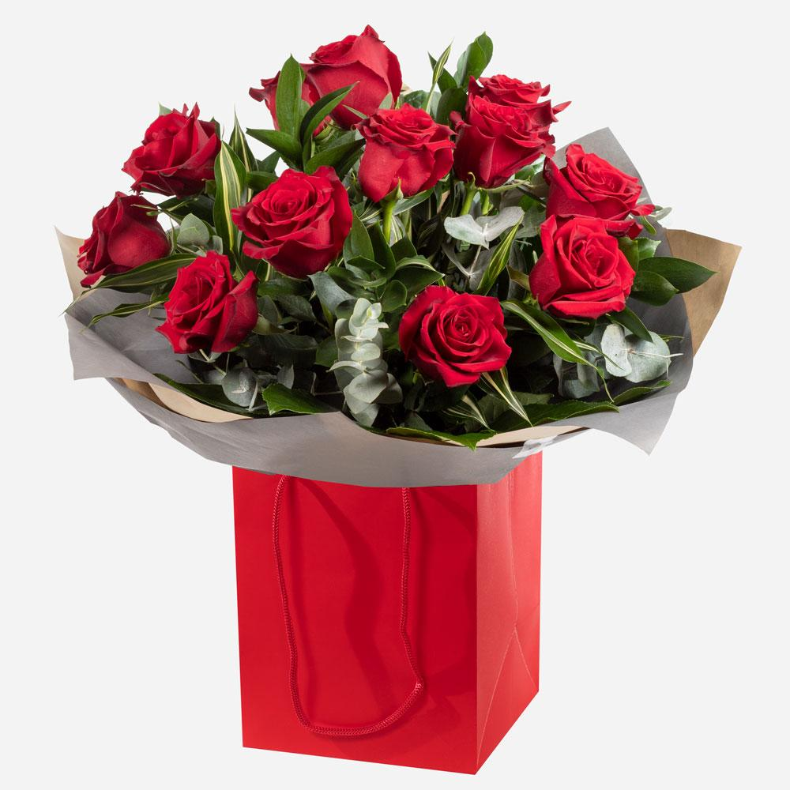

**For My Sweetheart**

12 luxury red roses and fabulous foliage are all you need to make a grand romantic gesture to your sweetheart.

Standard £69.50

*Workroom desc*

12 luxury red roses eg. Naomi, Explorer. Hand-tied or arranged in Oasis with choice foliage and presented in a gift bag or box.

----

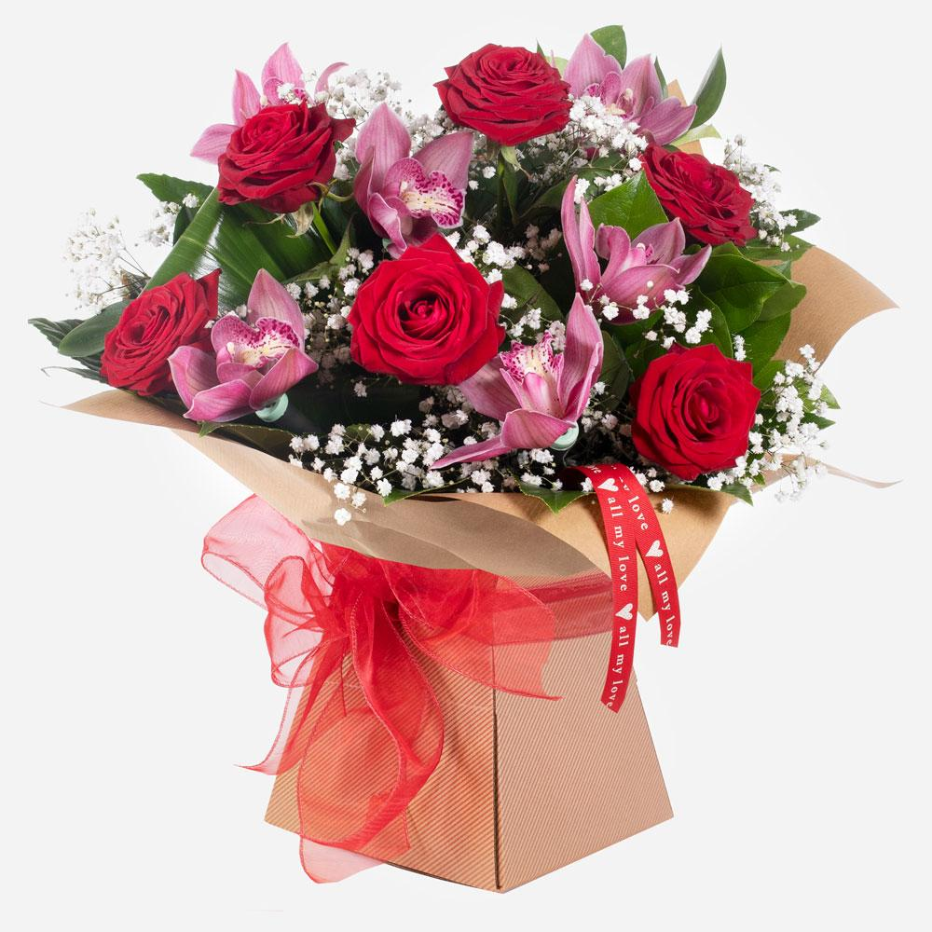

Mwah!

Standard £65

This gorgeous pairing of roses and orchids cannot fail to impress and give that special someone that loving feeling.

*Workroom:*

A hand-tied bouquet delivered in water in a gift box / bag of 6 high quality red roses and single headed orchids that have been put into water filled tubes on sticks. Complementary filler and foliage are added along with a novelty ribbon.

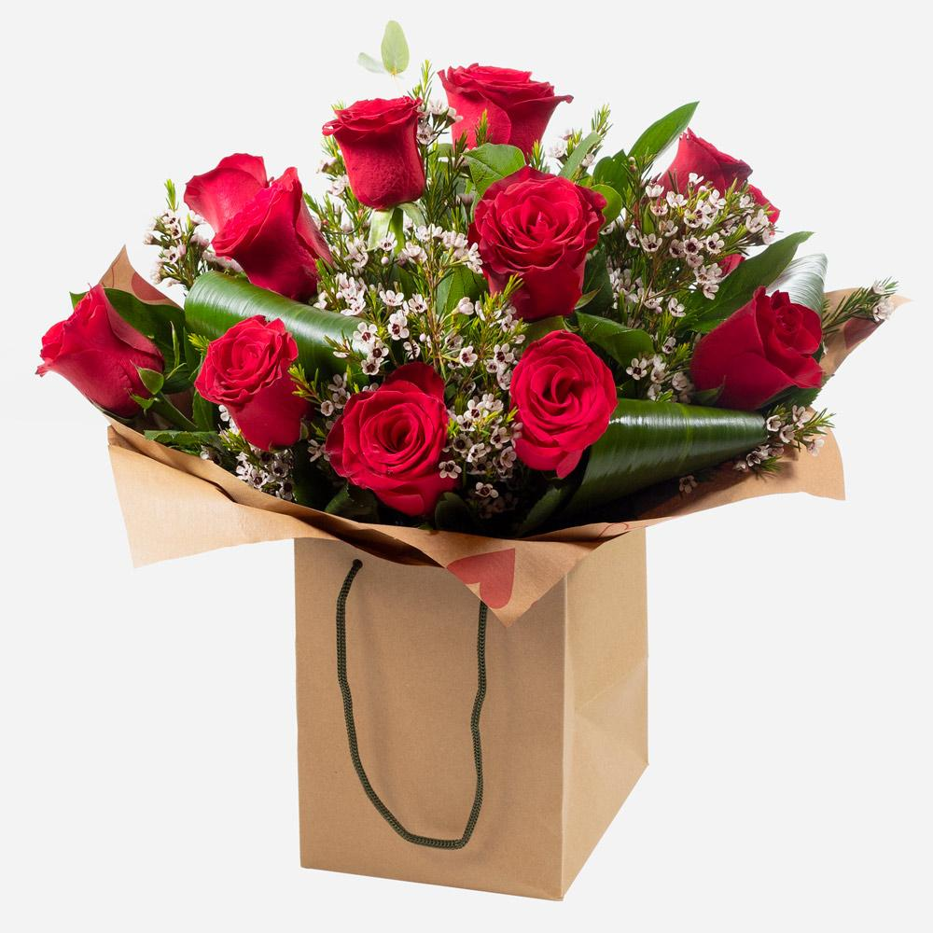

**P.s. I Love You**

Few gifts are as classically romantic as a dozen luxurious red roses, beautifully arranged and delivered in a gift bag or box.

Standard £55

*Workroom desc*

12 standard red roses with choice filler and foliage in a hand-tied or arrangement in Oasis and delivered in a gift bag or box.

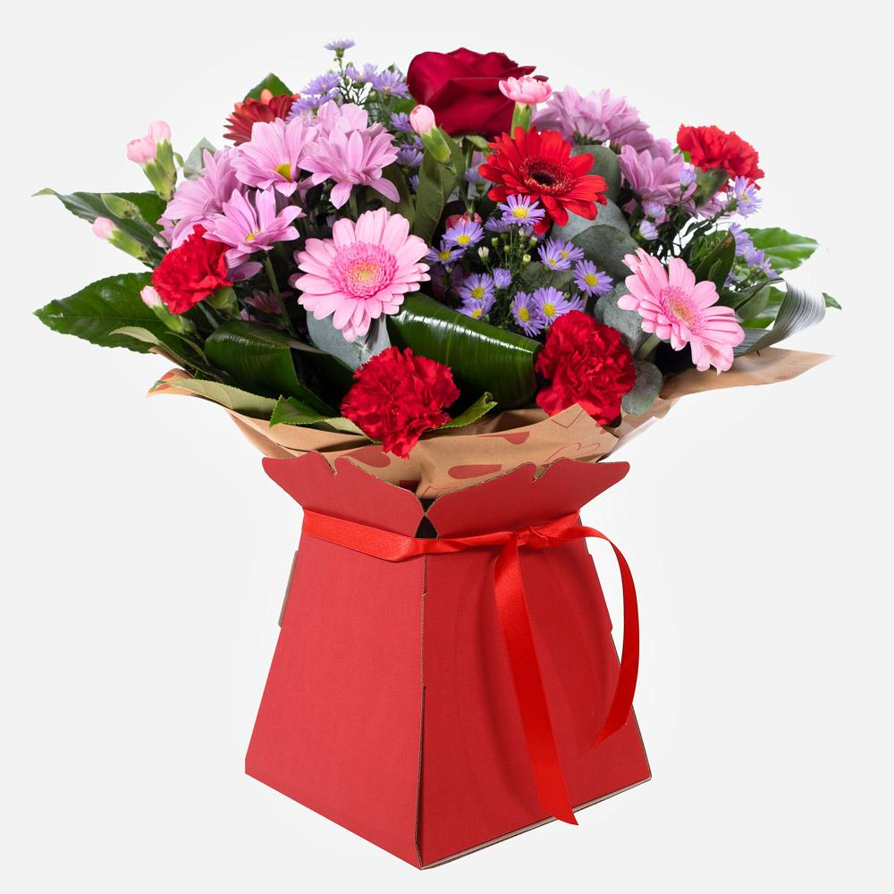

**Mrs Kisses**

Send lots of love and kisses with this classic hand-tied bouquet featuring a selection of romantic flowers finished with a luxurious single red rose.

Standard £44.50 / £54.50 / £64.50

*Workroom desc*

A pink and red hand-tied or arrangement in Oasis to include a single red rose to be delivered in a gift bag or box.

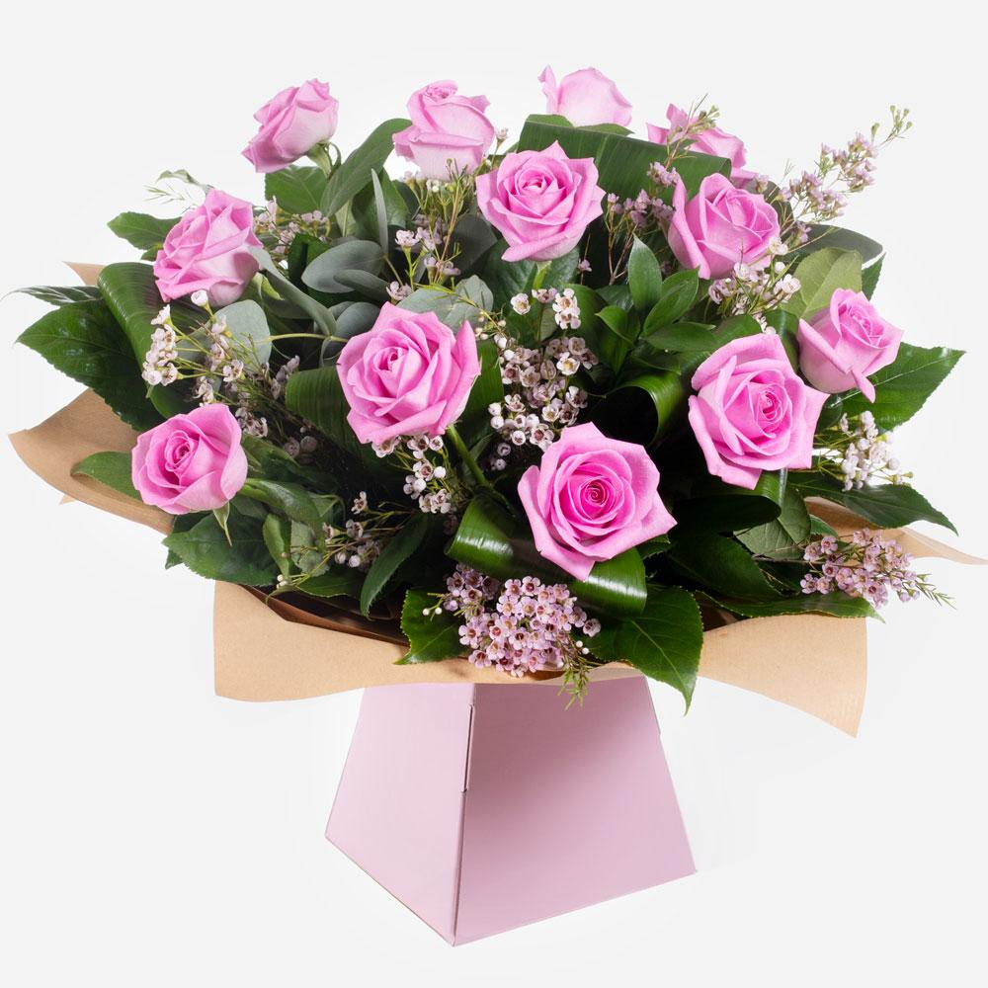

**Dreamy Dozen**

Standard £65

A sensational array of roses hand-tied and beautifully presented. This star of the florist just demands adoration and is sure to wow the recipient.

*Workroom:*

A hand-tied bouquet delivered in water of 12 high quality pink roses and complementary filler wrapped in paper/ cellophane in a box / bag.

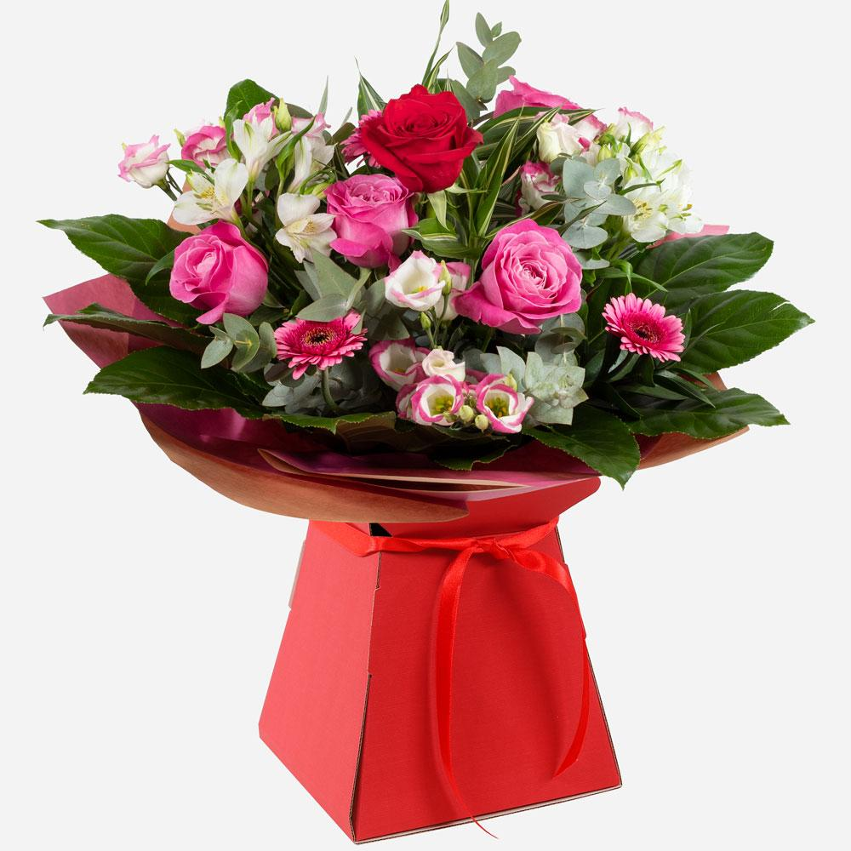

**Secret Admirer**

Send this beautiful collection of romantic flowers, expertly arranged to say “I love you” in an unforgettable way.

Standard £44.50 / £54.50 / £64.50

*Workroom desc*

A hand-tied or arrangement in Oasis of pink roses and mixed pink and white flowers and foliage to include a single red rose. Presented in a gift box or bag.

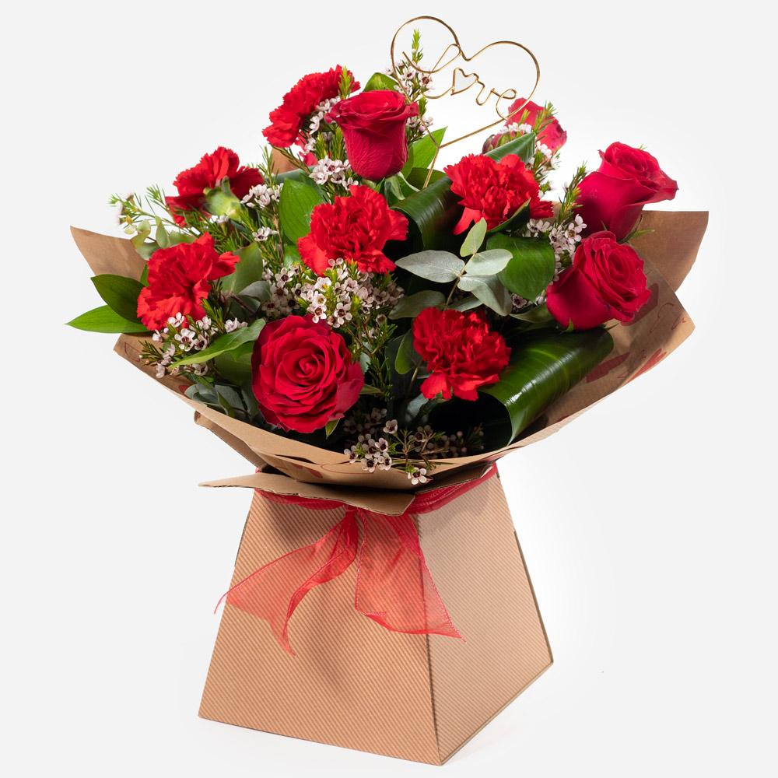

**Smooch**

Roses and carnations make the perfect couple when combined in this timeless and romantic gift that’s sure to impress.

Standard £49.50

*Workroom desc*

6 red roses and 6 red carnations with choice filler and foliage in a hand-tied or arrangement in Oasis and presented in a gift bag or box. A novelty item is added.