Mother’s Day 2022

Tutti Fruit

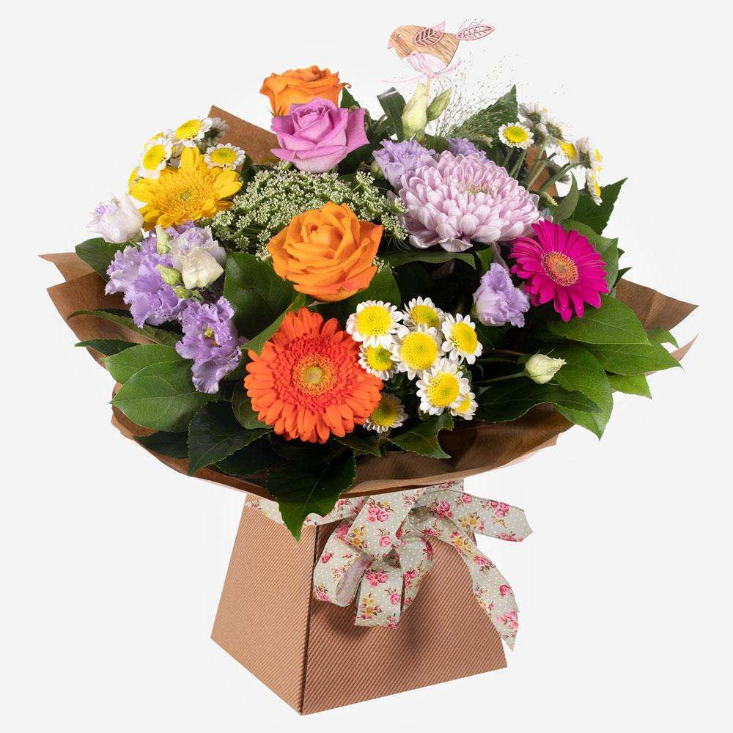

Standard £49.50 / £59.50 / £69.50
Desc

This charming hand-tied floral arrangement looks good enough to eat. A delicious array of blooms with heads held high supported with glorious greenery.

Workroom:
A hand-tied bouquet delivered in water in a box / bag wrapped in complementary paper / cellophane. A collection of high end luxury vibrant multi-coloured flowers were used.
A novelty pick was added to enhance the design.

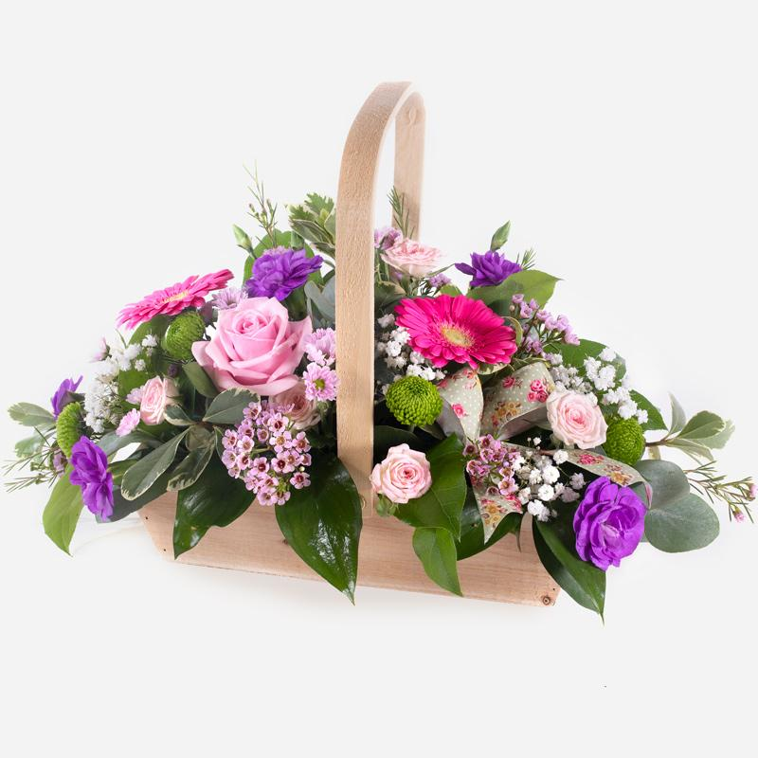
Bon Bon

Standard £39.50/£49.50/£59.50

Shower them with love with this cutesy collection of seasonal flowers in pretty pastels. Beautifully arranged and stylishly presented in a traditional basket.

Workroom:
An arrangement in a handled basket in foam / other using pastel traditional shaded flowers. A fabric bow was used to enhance the design.
Top tip: Make the design with long lasting foliage before completing the design with choice flowers.

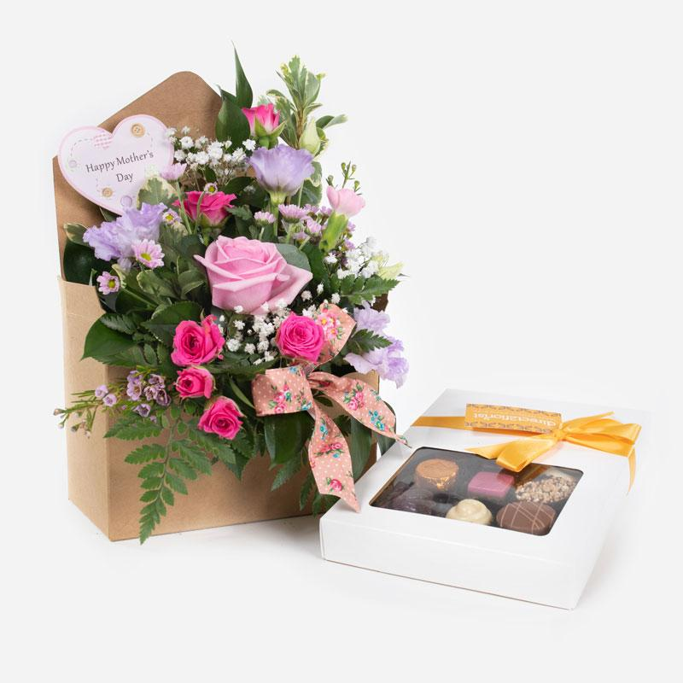

Candy Hearts & Chocolates

Deliver your messages of love the best way possible in this fabulous design arranged in a special gift box accompanied by delicious chocolates.
Standard £37.50

Workroom desc
A kraft envelope with lined plastic inner was filled with foam/other. The design was made with foliage before completing with traditional shaded pastel flowers. A novelty pick and fabric bow were used to enchanted the design.
This product is delivered with a box of quality chocolates.

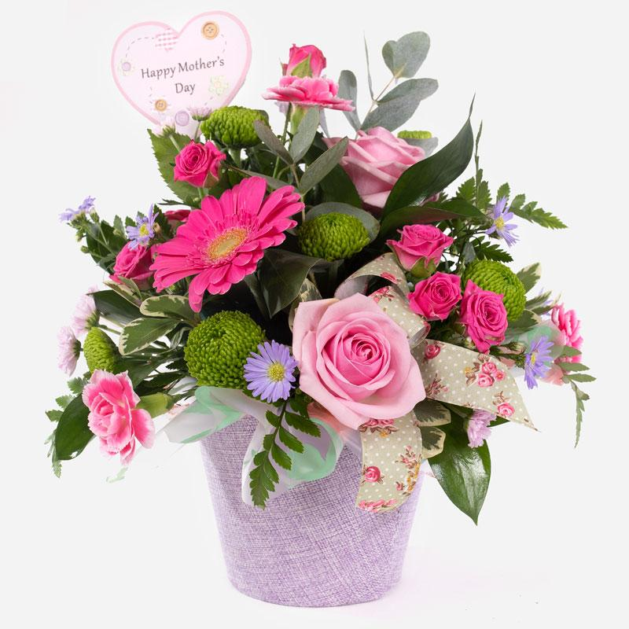

Cotton Candy
Standard £36.50/£44.50/£49.50

This little pot of sweetness is a joy to behold. Filled with smiling flowers and a complement of variegated foliage.

Workroom:
A jute plant pot cover or similar is lined and filled with foam / other to come just above the rim of the pot by approximately 2cm.
The arrangement of traditional pastel shaded flowers is front facing. A fabric bow is used to enhance the design.
Top tip: make the arrangement in long lasting foliage before completing with the flowers.

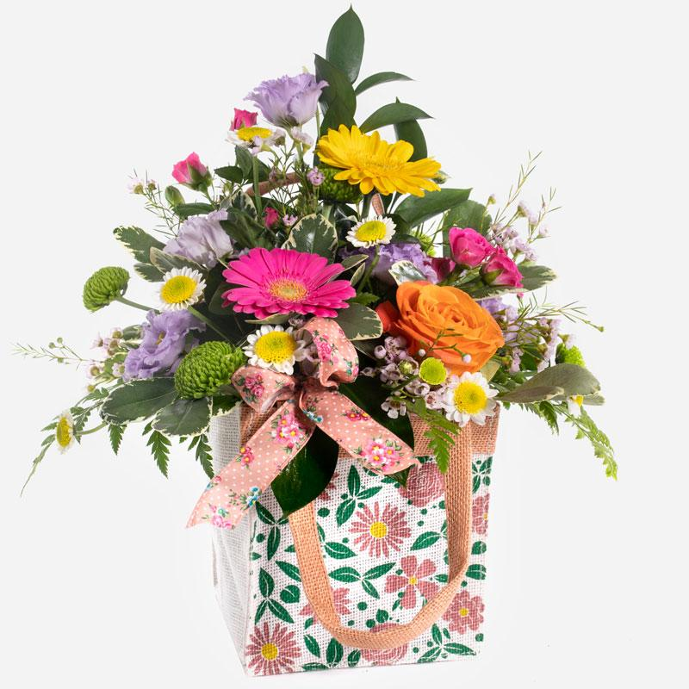

Dolly Mix
Standard £36.50/£44.50/£49.50

A delicious mixture of the finest flowers, forward facing and packed full of charm and loveliness to make their day.
Workroom:
A block of foam was placed in the jute bag. The protruding end was cut off by approximately 5 cm and sliced up to provide packing around the sides of the block to secure the foam. Multi coloured vibrant flowers were used to make a front facing arrangement. A fabric bow was used to enhance the design.
Top tip: Make the design in long lasting foliage before completing with flowers.

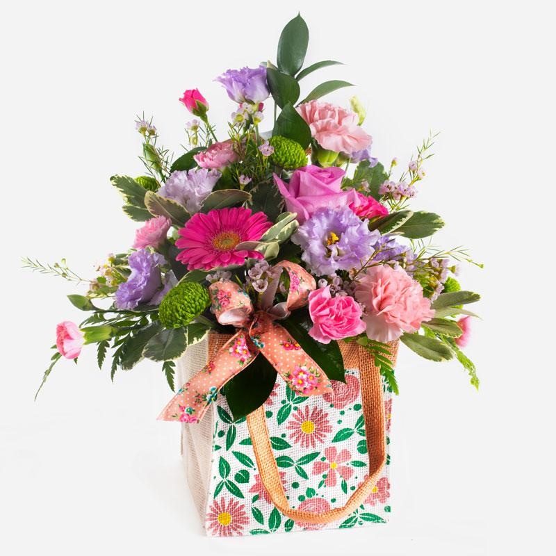

Fruit Pastel

Standard £36.50/£44.50/£49.50
Desc

Sweeten their day by sending them this gorgeous front facing medley of prettiness. Show them how much they mean to you with this stunning arrangement.

Workroom:
A block of foam was placed in the jute bag. The protruding end was cut off by approximately 5cm and sliced up to provide packing around the sides of the block to secure the foam. Traditional shaded flowers were used to make a front facing arrangement. A fabric bow was used to enhance the design.
Top tip: Make the design in long lasting foliage before completing with flowers.

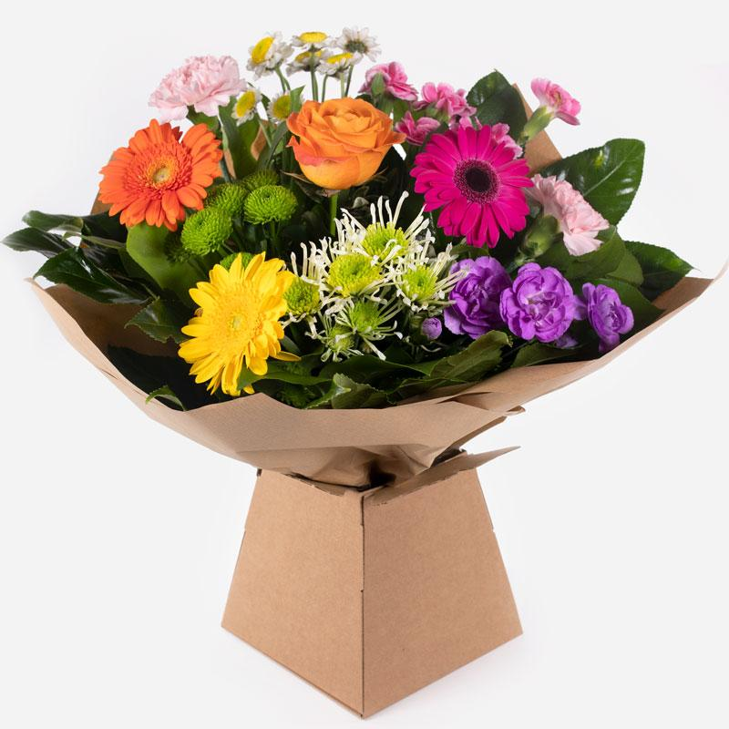

Jelly Bean
Standard £39.50/£49.50/£59.50

This amazing profusion of colour is bound to brighten the dullest of days. A vibrant and joyful floral gift with character in abundance.

Workroom:
A hand-tied bouquet delivered in water in a box / bag wrapped in complementary paper / cellophane of vibrant multi coloured flowers.
A novelty pick was added to enhance the design.

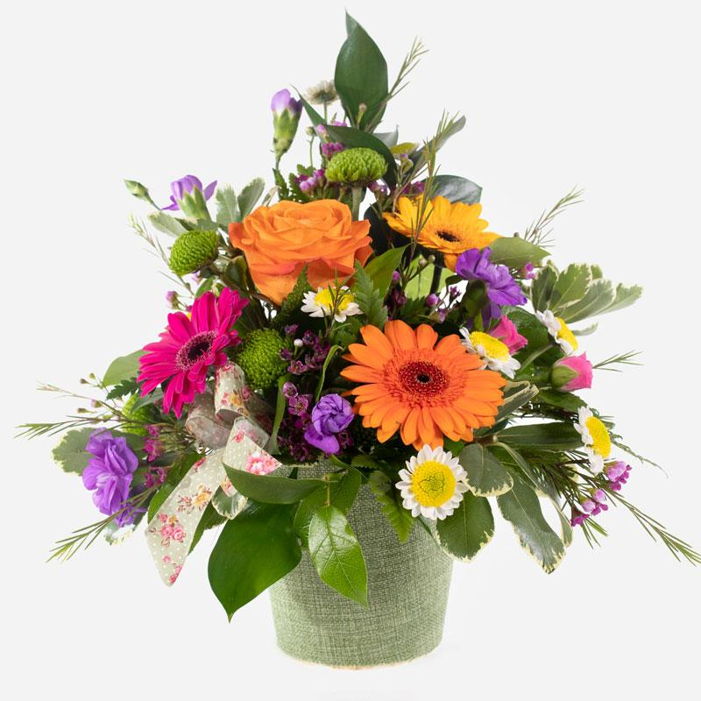

Jelly Tots
Standard £36.50 / £44.50 / £49.50

A floral arrangement that is as cute as candy and twice as sweet. A delightful collection of pretty blooms and luxury greens to bring joy for any occasion.

Workroom:
A jute plant pot cover or similar is lined and filled with foam / other to come just above the rim of the pot by approximately 2cm.
The arrangement of vibrant multi coloured flowers is front facing. A fabric bow was used to enhance the design.
Top tip: Make the arrangement in long lasting foliage before completing with flowers.

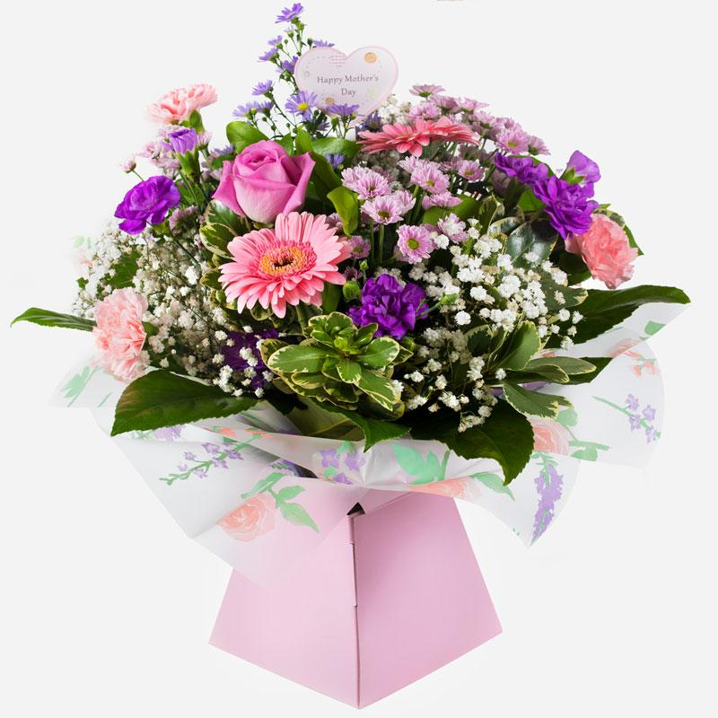

Pear Drops

Standard £39.50/£49.50/£59.50
Desc
A splash of sweet seasonal blooms arranged with style and beauty. This stunning hand tied arrangement will delight anyone lucky enough to receive it.
Workroom:
A hand-tied bouquet delivered in water in a box / bag wrapped in complementary paper / cellophane of traditional pastel shaded flowers.
A novelty pick is added to enchante the design.

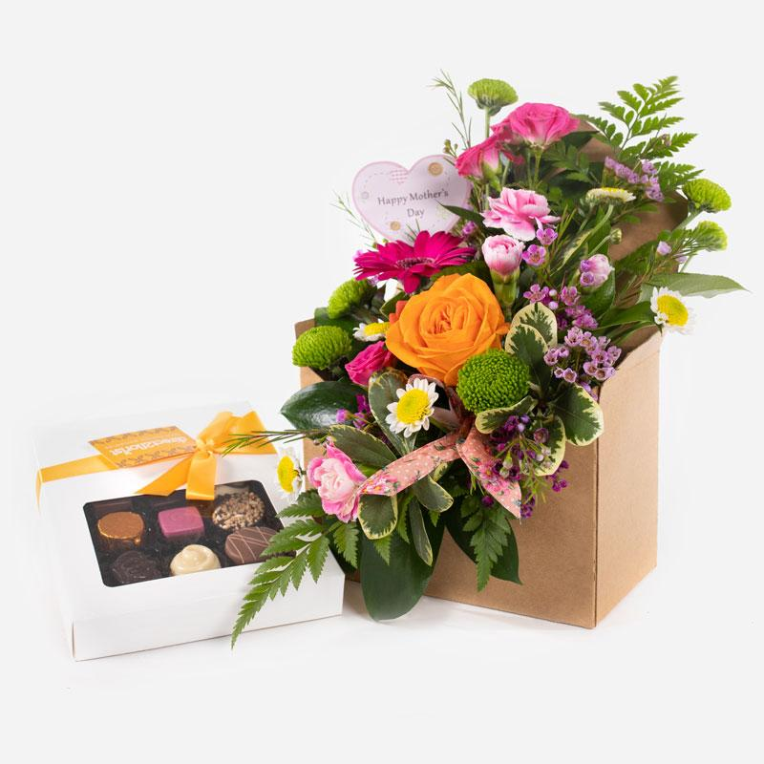

Rainbow Drops & Chocolates

Standard £37.50

A delightful arrangement of seasonal flowers delivered with luxury chocolates. What’s not to love about such an imaginative floral gift suitable for any occasion.

Workroom:
A kraft envelope with lined plastic inner was filled with foam / other was made with foliage before completing with vibrant multi coloured flowers. A novelty pick and fabric bow was used to enhance the design.
This product is delivered with a box of quality chocolates.

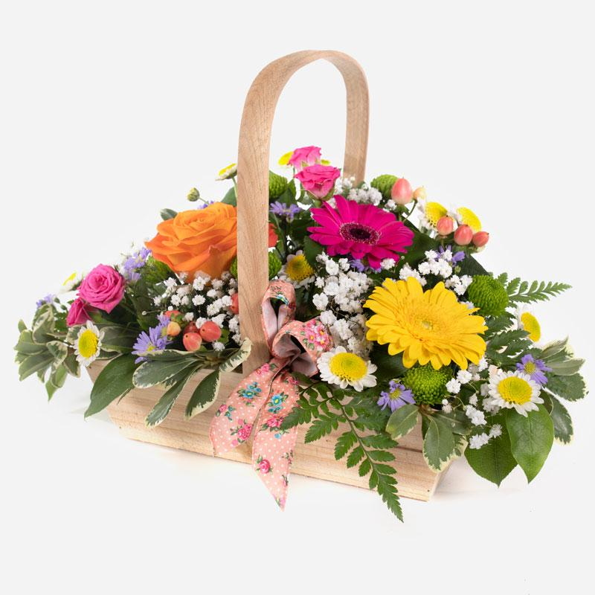

Sherbet Twist

Standard £39.50/£49.50/£59.50

This delightful collection of seasonal blooms is a beautiful way to send your affections. A pretty arrangement in a classic basket simply fizzing with joy and character.

Workroom:
An arrangement in a handled basket in foam / other using vibrant multi coloured flowers. A fabric bow was used to enhance the design.
Top tip: Make the design with long lasting foliage before completing the design with choice flowers.
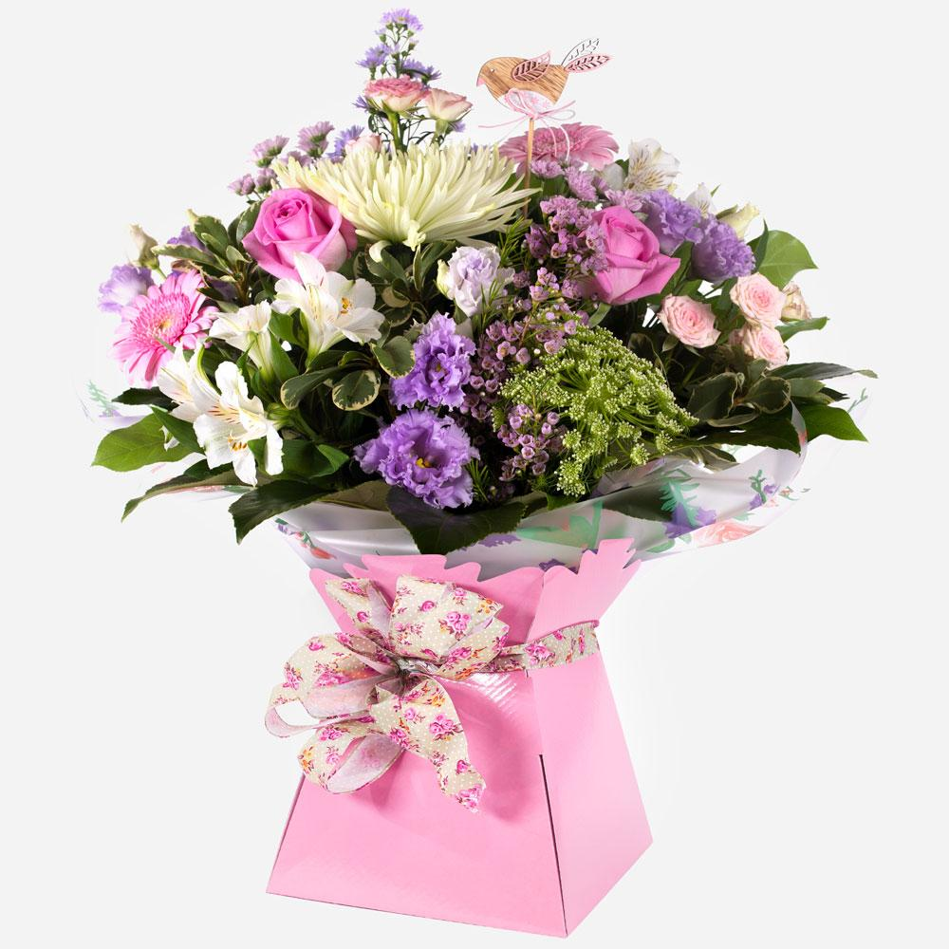

Sugar Rush

Standard £49.50 / £59.50 / £69.50

This gorgeous hand-tied bouquet of sweet pastel shades is sure to bring joy and delight. Crammed with beautiful flowers guaranteed to put a boost into any occasion.
Workroom:
A Hand-tied bouquet delivered in water in a box / bag wrapped in complimentary paper / flowers. A collection of high end luxury traditional pastel shaded flowers were used.
A novelty pick was added to enhance the design.

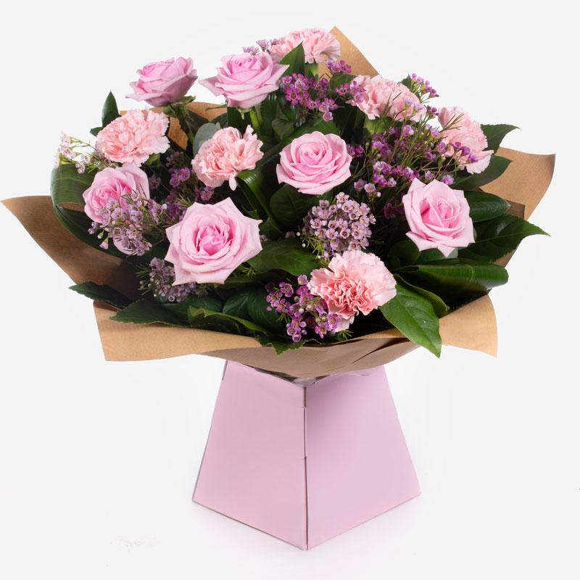

Strawberry Twist

Standard £49.50

This sweet arrangement of roses with carnations and foliage to compliment. Your recipient is sure to be overjoyed at such a heartfelt statement.

Workroom:
A hand-tied bouquet delivered in water of 6 high quality pink roses and 6 pink carnations with complementary filler wrapped in paper / cellophane in a box or bag.

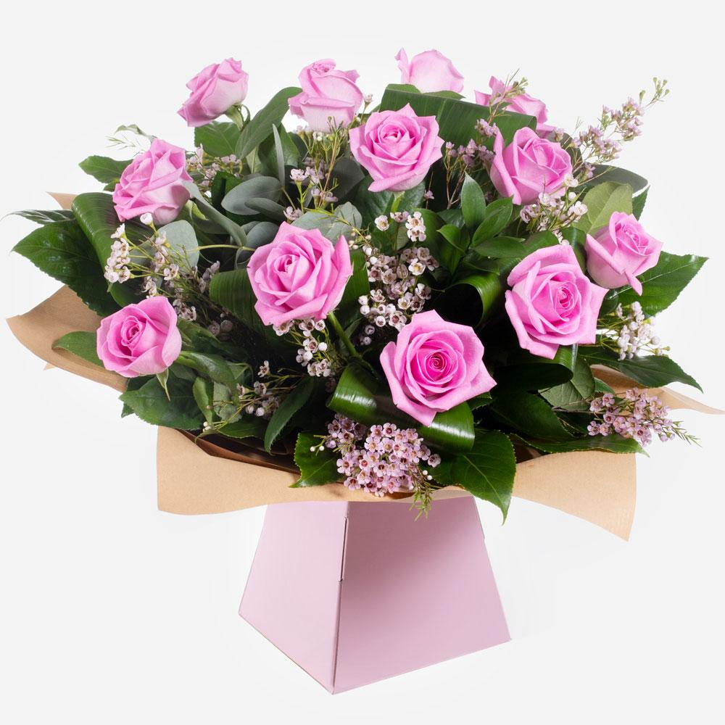

Dreamy Dozen

Standard £59.50

A sensational array of roses hand-tied and beautifully presented. This star of the show is sure to wow the recipient.

Workroom:
A hand-tied bouquet delivered in water of 12 high quality pink roses and complementary filler wrapped in paper/ cellophane in a box / bag.

